Infrared

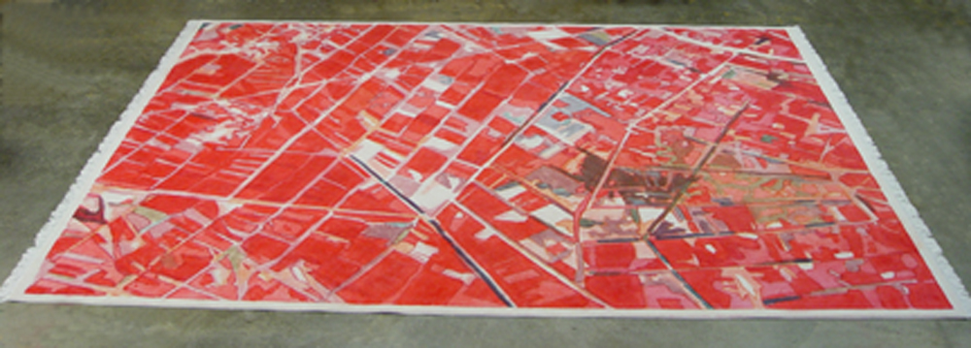
33º 26’ 53.59”N 44º12’ 41.92”E (Ibrahim ‘Ali), Acrylic and Fabric Dye on Carpet, 15’ X 12’, 2007

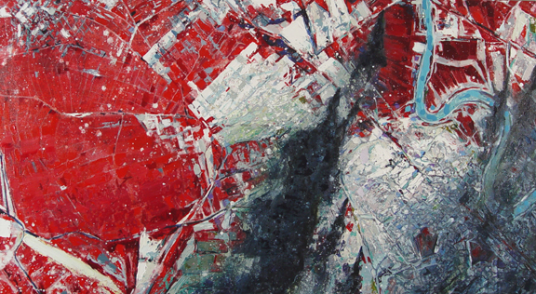
33º 23’ 31.43”N 44º 16’ 11.25”E (Kadhimiya), Acrylic and Oil on Canvas, 48” X 26”, 2007

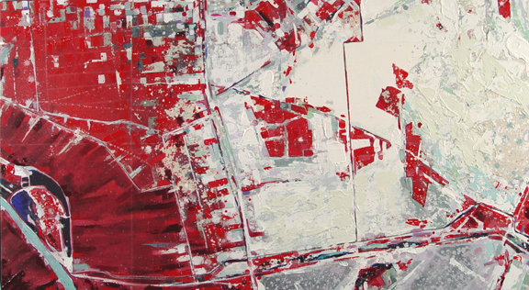
33º 27’ 00.30”N 44º 23’ 25.46”E (Hayy Adan), Acrylic and Oil on Canvas, 48” X 26”, 2007

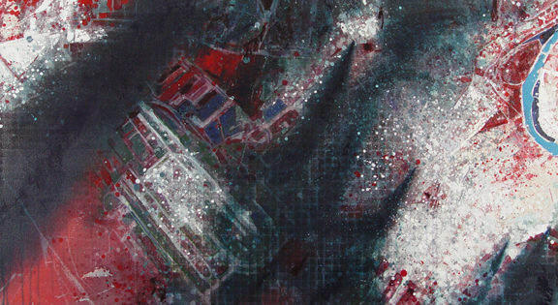
33º 16’ 40.09”N 44º 16’ 24.96”E (BIAP/Al Jahid), Acrylic and Oil on Canvas, 48” X 26”, 2007

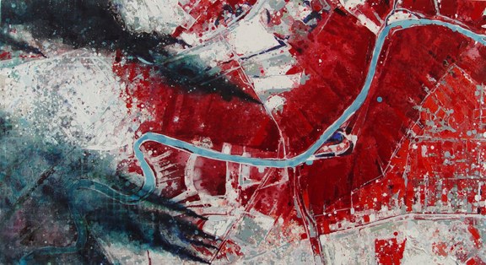
33º 24’ 53.37”N 44º 20’ 15.21”E (Haifa), Acrylic and Oil on Canvas, 48” X 26”, 2007

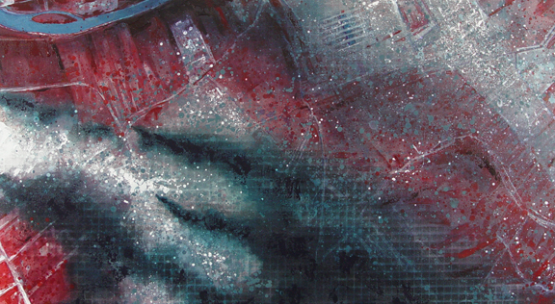
33º 13’ 31.56”N 44º 25’ 05.12”E (Al Muradiyah), Acrylic and Oil on Canvas, 48” X 26”, 2007

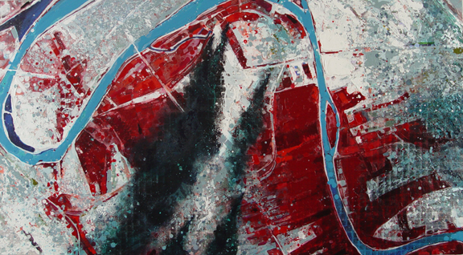
33º 15’ 49.66”N 44º 25’ 43.03”E (Karada), Acrylic and Oil on Canvas, 48” X 26”, 2007

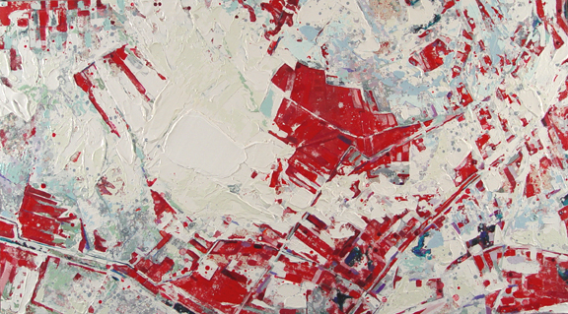
33º 25’ 55.20”N 44º 29’ 48.86”E (Sadr), Acrylic and Oil on Canvas, 48” X 26”, 2007

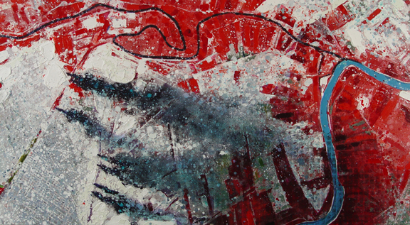

33º 15’ 042.24”N 44º 29’ 52.54”E (Diyala), Acrylic and Oil on Canvas, 48” X 26”, 2007

